Set 11 – Product Category Analysis
Aim
To analyze product category sales using a funnel chart, pie chart, table, and an interactive Tableau dashboard.
Dataset: Product Categories
Category | Sales ($)
Electronics | 50,000
Clothing | 35,000
Appliances | 40,000

PROGRAM 1: Product Category Sales Funnel Chart
Create a funnel chart to analyze the sales values for each product category.
R-Code:
# Create product category data
category <- c("Electronics", "Clothing", "Appliances")
sales <- c(50000, 35000, 40000)

# Sort sales in decreasing order
order_data <- order(sales, decreasing = TRUE)

category <- category[order_data]
sales <- sales[order_data]

# Create horizontal bar chart
barplot(sales,
names.arg = category,
horiz = TRUE,
main = "Product Category Sales Funnel",
xlab = "Sales ($)",
col = "skyblue",
border = "black",
las = 1)

# Add sales values
text(x = sales,
y = seq_along(sales),
labels = sales,
pos = 4)

Output:
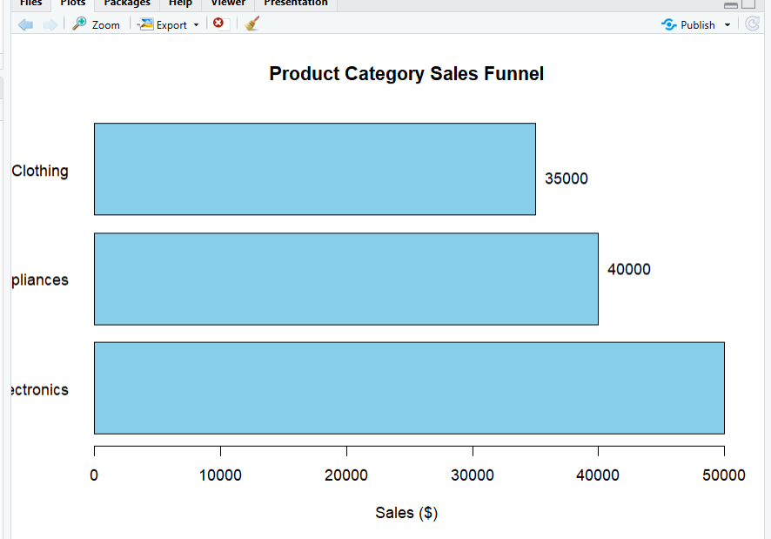
Output 1: Product Category Sales Funnel Chart
Observation
The funnel chart represents the sales values of the product categories. Electronics has the highest sales, while Clothing has the lowest sales.

PROGRAM 2: Product Category Sales Table
Build a table to display the sales data for each product category.
# Create product category data
product_data <- data.frame(
Category = c("Electronics", "Clothing", "Appliances"),
Sales = c(50000, 35000, 40000)
)

# Display the sales table
print(product_data)
Output:
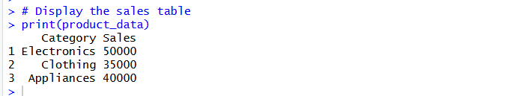
Output 2: Product Category Sales Table
Observation
The table clearly displays the product categories and their corresponding sales values.
PROGRAM 3: Tableau Dashboard for Product Category Analysis
Develop a Tableau dashboard combining the pie chart, funnel chart, and table for interactive exploration of product category data.
Procedure
- Create the product category dataset containing Category and Sales.
- Import the dataset into Tableau.
- Create a funnel-style chart using Category and Sales.
- Create a pie chart using Category and Sales.
- Create a table displaying Category and Sales.
- Create a new dashboard.
- Add the funnel chart, pie chart, and table to the dashboard.
- Add filters or dashboard actions for interactive exploration.
- Arrange the visualizations clearly.
- Add the title Product Category Sales Analysis Dashboard.
- Save the dashboard.

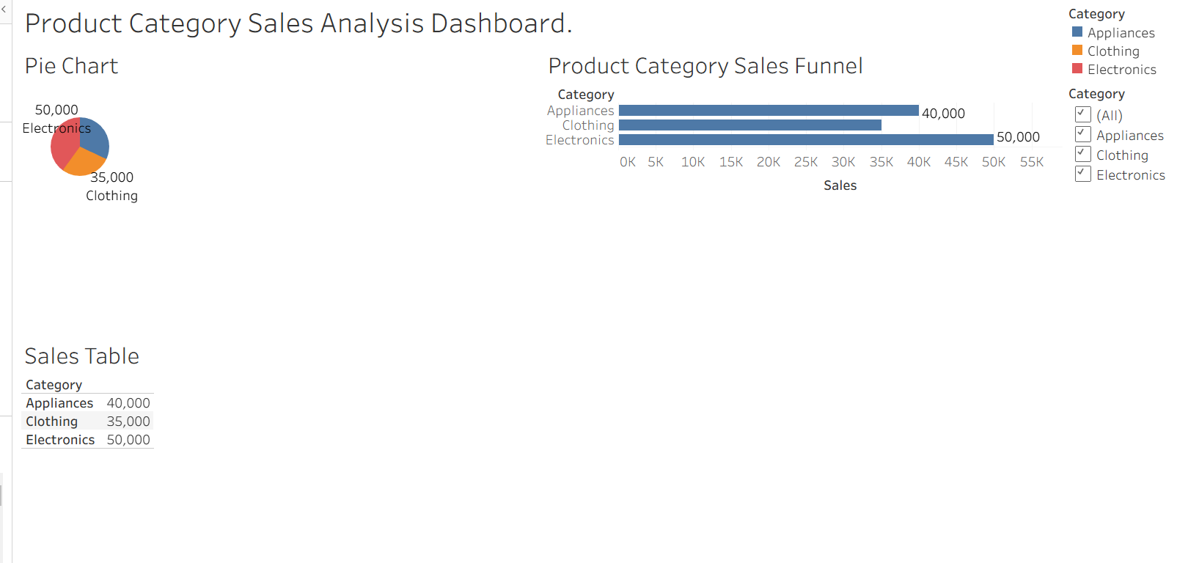
Output 3: Product Category Sales Analysis Tableau Dashboard
Observation
The dashboard displays product category sales using a funnel chart, pie chart, and table, allowing users to compare sales values and explore the product categories interactively.

PROGRAM 4: Product Category Sales Pie Chart
Create a pie chart to represent the distribution of sales across product categories.
R-code:
# Create product category data
category <- c("Electronics", "Clothing", "Appliances")
sales <- c(50000, 35000, 40000)

# Calculate percentages
percentage <- round(sales / sum(sales) * 100, 1)

# Create labels
labels <- paste(category, percentage, "%")

# Create pie chart
pie(sales,
labels = labels,
main = "Sales Distribution by Product Category",
col = c("skyblue", "pink", "lightgreen"))

# Add legend
legend("topright",
legend = category,
fill = c("skyblue", "pink", "lightgreen"))

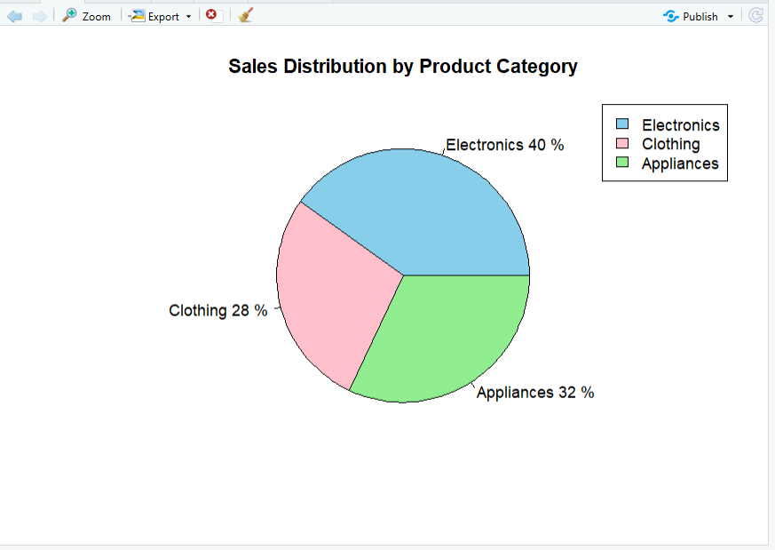
Output 4: Product Category Sales Distribution Pie Chart
Observation
The pie chart shows the distribution of total sales among the product categories. Electronics contributes the largest share of sales, while Clothing contributes the smallest share.

Set 11 Procedure
- Create the product category dataset containing Category and Sales.
- Use R to create a funnel-style chart showing sales for each category.
- Create a table to display the sales data for each category.
- Create a pie chart to represent the distribution of sales across product categories.
- Import the product category dataset into Tableau.
- Create the funnel chart, pie chart, and table in Tableau.
- Apply filters and dashboard actions for interactive exploration.
- Combine all three visualizations into a dashboard and save it.
Set 11 Result
Product category sales data was successfully visualized using a funnel chart, pie chart, and sales table. A Tableau dashboard was also created to display and interactively explore sales across different product categories.

